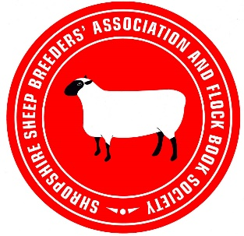
Ram Hire or AI Quick Reference Guide
If you hire a ram to use on your ewes or use AI you need to make a note of what you need to do to enable you to birth notify their offspring.
For data accuracy Grassroots does not allow you to birth notify or register offspring born from rams that don’t belong to you unless it has been previously notified of the mating. This also applies if you sell or kill off a ram before notifying the births.
To do this either, add the mating’s to Grassroots via the “ewes to ram” menu option in the on line registry or, complete form SSBA8, downloadable from the website at https://www.shropshire-sheep.co.uk/memers-page/publications-and-forms/ and send it to the registrations clerk at registrationsclerk@shropshire-sheep.co.uk

Hire a Ram
When you send a ram back after the hire, it is best practice to take a list of all the ewes eartags or reg numbers that you used the ram on, give this to the owner of the ram and they can add the matings to Grassroots via the method above. Alternatively download form SSBA8, fill in the details and get the owner to sign it then send to the registrations clerk.

Sell or kill off a Ram
Whilst the ram is still in your ownership or alive add the matings to Grassroots via one of the two methods above then, you can sell or kill off the ram and still birth notify any offspring.

AI
When you have a ewe or ewes inseminated form SSBA8 must be completed by the inseminator and a copy sent to the registrations clerk.

