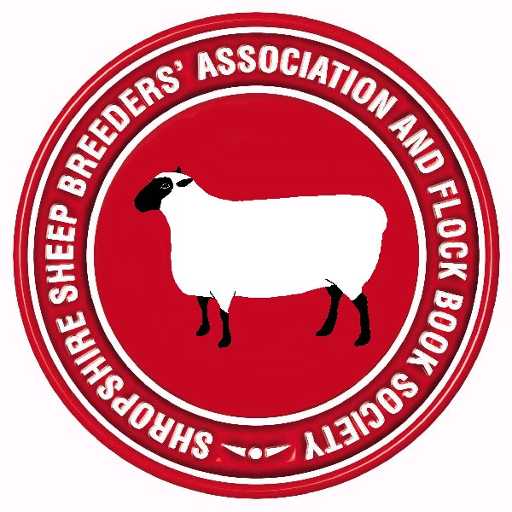

SHROPSHIRE SHEEP BREEDERS’ ASSOCIATION
AND FLOCK BOOK SOCIETY

OVERSEAS MEMBERSHIP APPLICATION FORM

I/we …………………………………………………………………………………..
(Please state Mr, Mrs, Miss and full name)
of…………………………………………………………………………………..…………………………………………………………………………………………..……………………………………………………………………………………………………………………………………………….…………………………………..…………
(please provide full postal address, including post code)
Telephone number: ………………………… Fax number……...................................
E-Mail………………………………………………………………………………….
wish to become an Overseas Member of the Shropshire Sheep Breeders’ Association and Flock Book Society, and agree to pay the annual Overseas Membership Subscription of £40. Please note that Overseas members are not entitled to the voting rights of full members of the SSBA.
Date:
When completed, this form should be returned by e-mail to the Secretary of the Association :
Mr. S. Mackay and send email to secretary@shropshire-sheep.co.uk with the reference and
payment date

Payment Methods -
Paypal - You will then receive an e-mail from the Treasurer, requesting payment for the above amount. All you need to do is click on the link in that e-mail message, to make the payment via PayPal.
Bank Transfer – Bank : Barclays Leicester
IBAN – GB58 BARC 2049 0810 3450 08 SwiftBIC : BARCGB22

For Official Use:
Treasurer  Informed |  | Registrar  informed |  | Membership pack sent

Registered Charity Number 1115599

